

PRE BOARD EXAMINATION 2019 MARCH
Bachelor Level/First Year/I Semester Full Marks: 60
Computer Science and Information Technology Pass Marks: 24
Digital Logic Time: 3 Hours
Examination Date: 27th, Mar, 2019

Candidates are required to give their answers in their own words as for as practicable.
The figures in the margin indicate full marks.
SET A

Group "A"
(Long Answer Question Section)
Attempt any TWO questions. (2x10=20)

- Implement the following function F=Ʃ(0,1,3,4,7) using
a) Decoder
b) Multiplexer
c) PLA

- Differentiate between synchronous and asynchronous sequential circuit. Design a counter as shown in the state diagram below
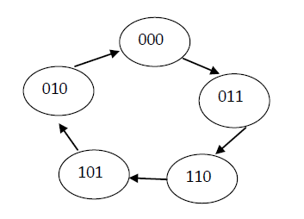
111

001
- Explain different types of shift registers with necessary diagrams.

Group "B"

(Short Answer Question Section)
Attempt any EIGHT questions. (8x5 = 40)
- Express the complement of the following function in sum of minterms.
F(A,B,C,D) = ∑(0,2,6,11,13,14)

- Reduce the following function using k-map
F = wxy + yz + xy’z + x’y
- Design a combinational circuit with three inputs and six outputs. The output binary number should be square of the input binary number.
- Design a 5x32 decoder with four 3x8 decoder with enable and one 2x4. Use block diagrams only.
- Perform the arithmetic operations (+42) + (-12) and (-42)-12 in binary using the signed 2’s complement representation for negative numbers.
- Convert (2AC6)16 to decimal, octal and binary.
- Explain master slave J-K flip flop.
- Design full subtractor.
- Write short notes on (Any two)
  - T flip flop
  - PAL
  - TTL

